TOP

How do I cancel a shipment?
My contract is not in VSM.
How do I change a contract from origin to destination and vice versa?
How do I correct weight, dimensions or quantity on a shipment?
How do I correct a quantity in my Origin screen?
I am missing labels in my Print screen.
My labels won’t print in my Print screen.
I am locked out of my account.
I need a new password.
What is the status of my shipment?
My shipment was not picked up.
My shipment is not ready for pickup.
My Ship To code is incorrect.
My labels are incorrect.
The material I am shipping has a shelf life. Where do I enter the correct dates so that the shelf life will appear on the appropriate labels?

How do I cancel a shipment?
Vendors cannot cancel shipments. Send an email request to delivery@dla
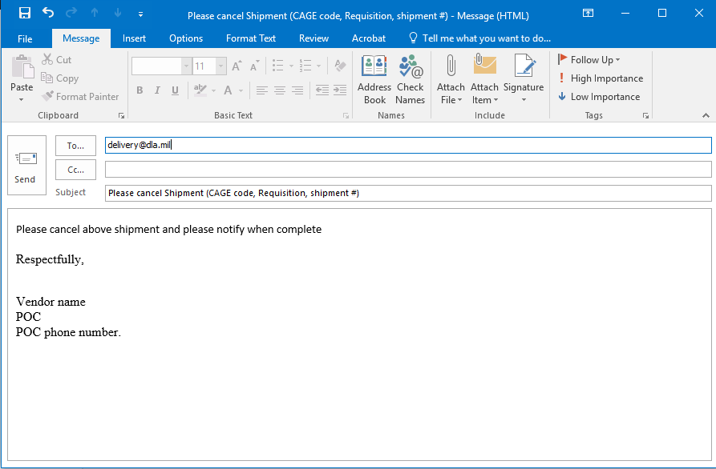

Back to Top

My contract is not in VSM.
Were you registered to use VSM prior to your contract award?
NO? Please register to access VSM at https://vsm.distribution.dla.mil
YES? Have a copy of your contract available, then
Go to the MPO (Manual Purchase Order) screen found in the heading ribbon of the VSM order entry page or contact the appropriate Contracting Officer Representative (COR) or Post Award Contract Administrator by completing a Post Award Request (PAR).
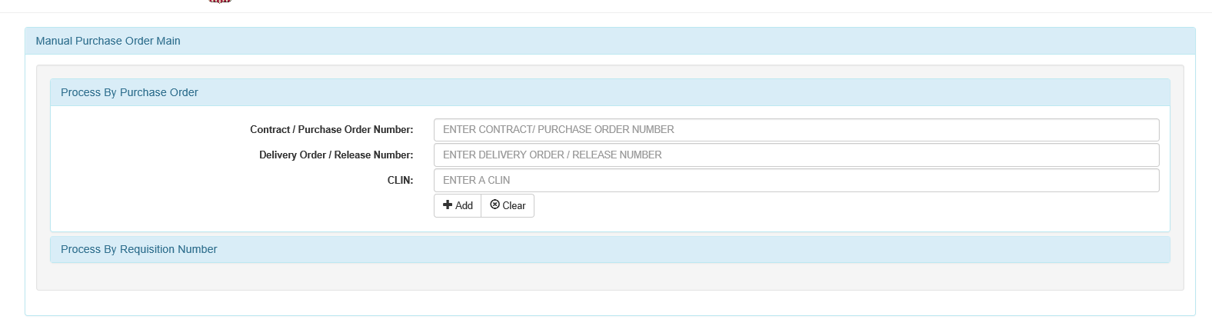
Enter your Contract/Purchase Order Number
Enter your Delivery Order/Release Number
Enter your CLIN
Then hit the Add button

OR you can process your MPO by Requisition number:
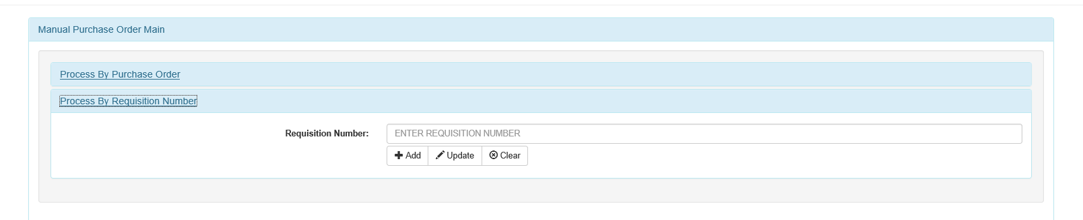
Enter your Requisition Number and hit Add

Enter contract # and CLIN
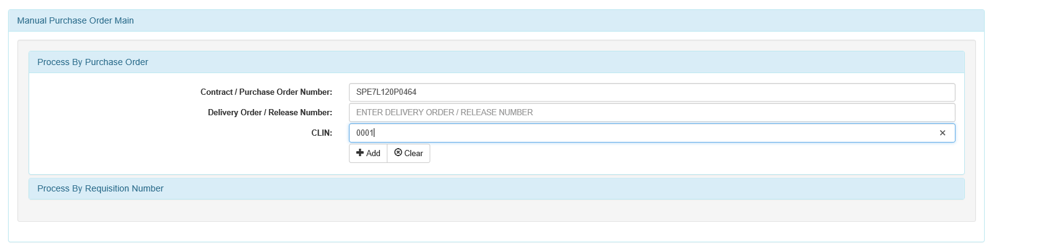

Enter contract # and CLIN then click ADD:
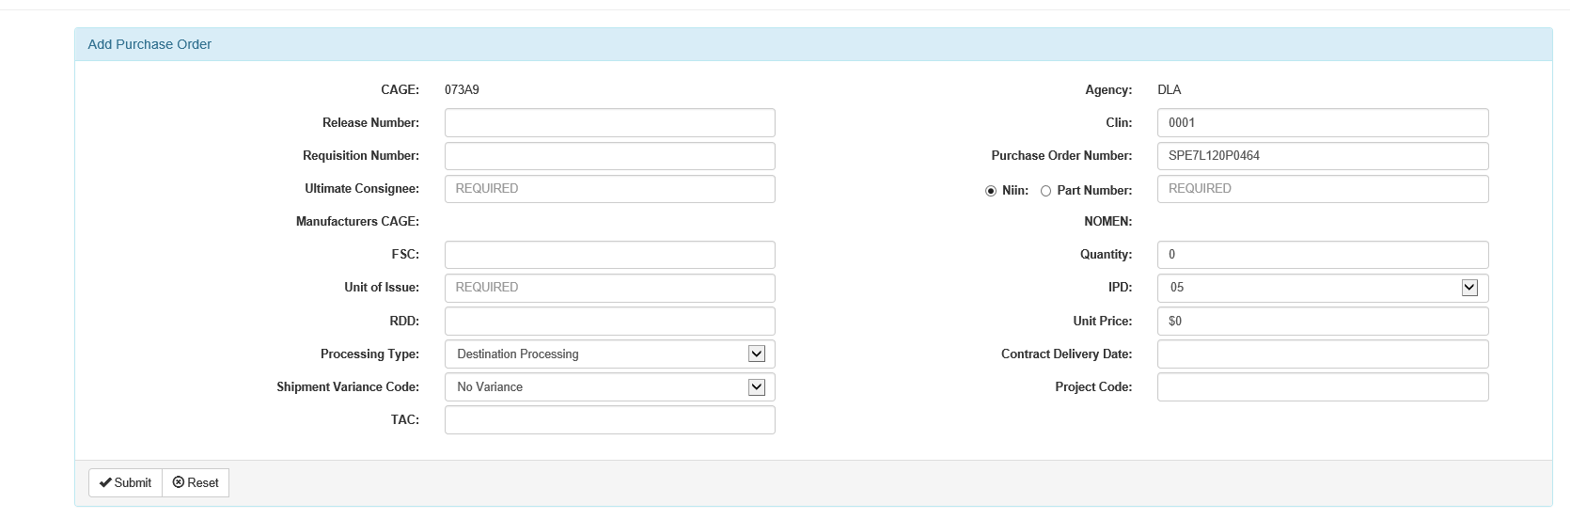
Input the Ultimate consignee
Input Requisition number
Input NIIN or part number (if part number add nomenclature)
Put manufacturer cage
Input unit of issue
Input Quantity
Input type of processing. (Default is Destination) If origin contract make origin
Input Unit price
Input Requisition number
Input CDD and RDD

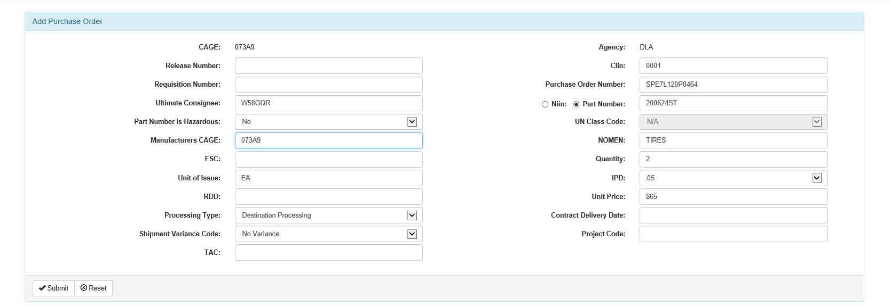
Hit submit
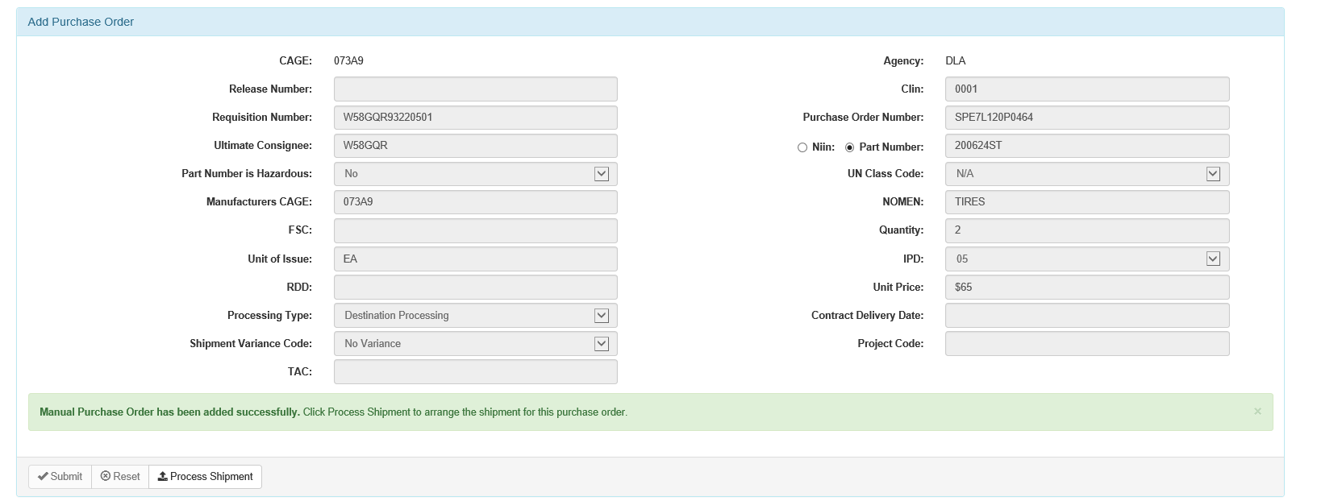

If input properly shipment should be available for processing. Indicated by green line.

Adding MPO by Requisition number

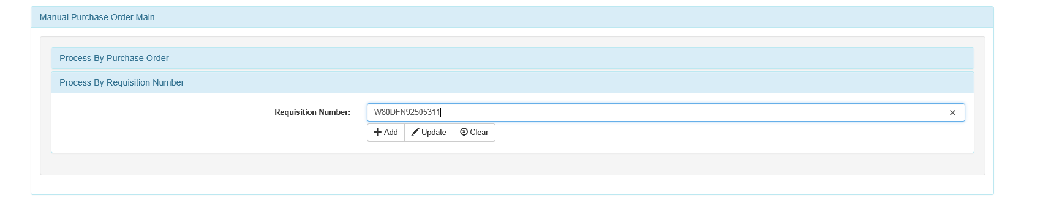
Input Requisition number hit ADD:
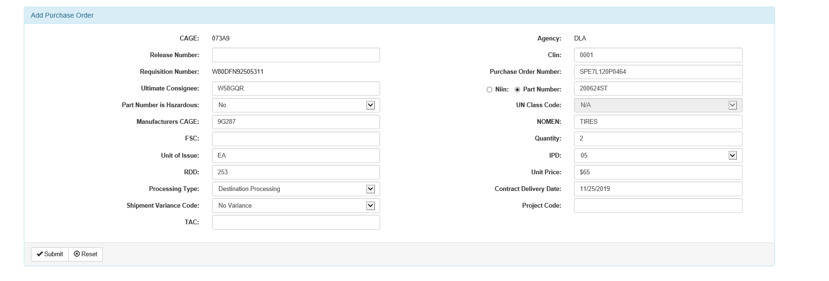
Input the Ultimate consignee
Contract Number
Input CLIN:
Input NIIN or part number (if part number add nomenclature)
Put manufacturer cage
Input unit of issue
Input Quantity
Input type of processing. (Default is Destination) If origin contract make origin
Input Unit price
Input Requisition number
Input CDD and RDD

Hit submit

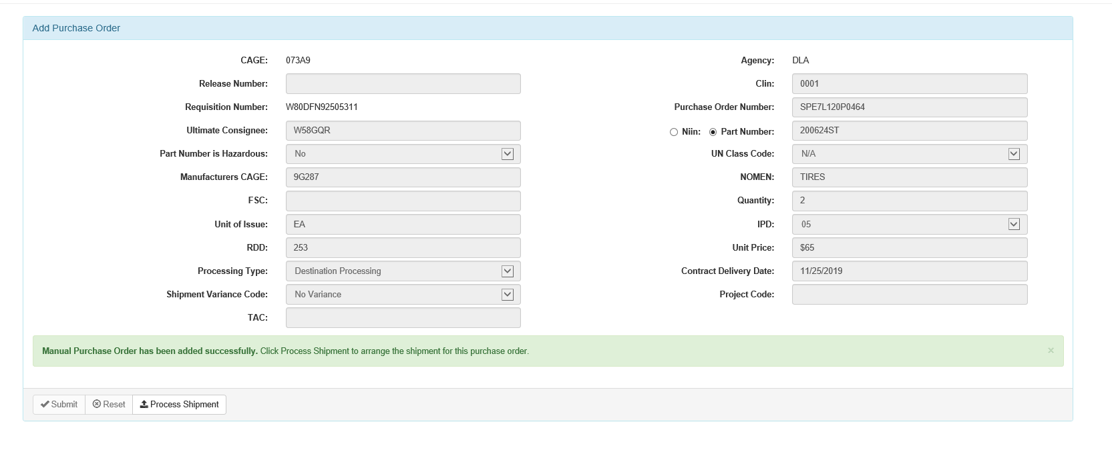
If input properly shipment should be available for processing. Indicated by green line.
Back to Top

How do I change a contract from origin to destination and vice versa?
- Is your contract an Origin or Destination Contract? If it is a Destination contract you need to contact your Contracting Officer Representative (COR) or Post Award Contract Administrator via a Post Award Action Request (PAR) and request a modification be completed to make it an Origin contract.
- Contract modifications automatically flow into VSM, but in some cases you may have to cancel the shipment and reprocess it as an Origin shipment by completing a Manual Purchase Order and clicking on the processing type there. This will also include ensuring all the rest of the information is in there as well.
- You may be able to change an Origin shipment to a Destination shipment just by updating the MPO by clicking on MPO, but if an order requires cancellation prior to reprocessing, VSM must be contacted by email at delivery@dla.mil
After clicking on MPO click on process by Requisition Number
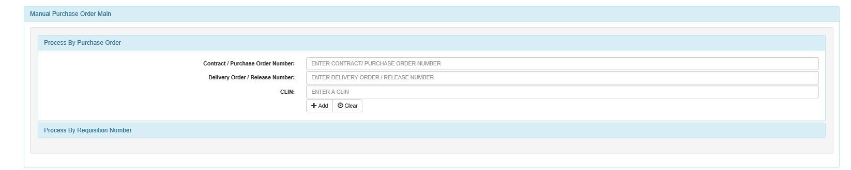

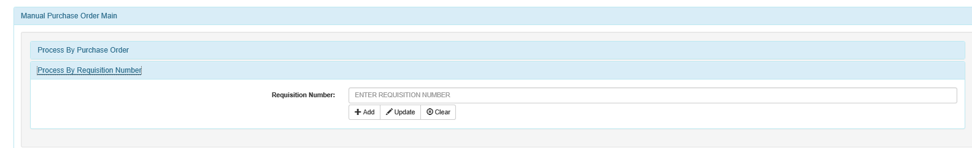
Then enter Requisition Number and hit Update
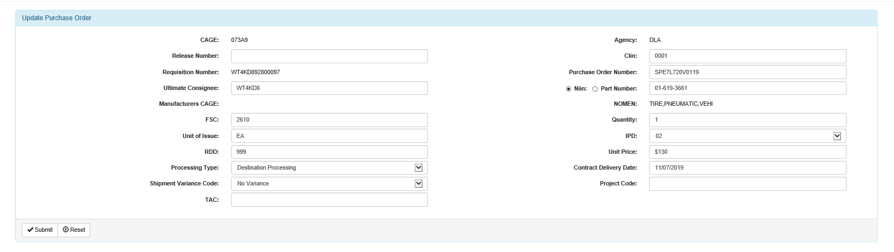
Click the dropdown menu and change the Processing Type to Origin/Destination. Then hit submit and then you can process your shipment in the Origin Processing section.

Back to Top

How do I correct weight or dimensions on a shipment?
- Follow process to Cancel Shipment.
- Once cancelled, reprocess shipment to enter correct information.

Back to Top

How do I correct a quantity in my FOB Processing screen?
- Follow process to Cancel Shipment.
- Update the MPO via Requisition # and correct the quantity and hit the submit button.
- This will correct the quantity and then process the shipment.

Back to Top

I am missing labels in my Print screen.
- Contact VSM by contacting the appropriate agency:
  - DLA 1-800-456-5507 or email: delivery@dla.mil
  - DCMA 1-314-331-5573 or email: dcma.stlouis-mo.central-rc.mbx.VSM-Shipments-Transportation@mail.mil?subject=DCMA Customer Support

Back to Top

My labels won’t print in my Print screen.
- Contact VSM by contacting the appropriate agency:
  - DLA 1-800-456-5507 or email: delivery@dla.mil
  - DCMA 1-314-331-5573 or email: dcma.stlouis-mo.central-rc.mbx.VSM-Shipments-Transportation@mail.mil?subject=DCMA Customer Support

Back to Top

I am locked out of my account. I need a new password.
- If locked out of account for 30 days or less use the password reset
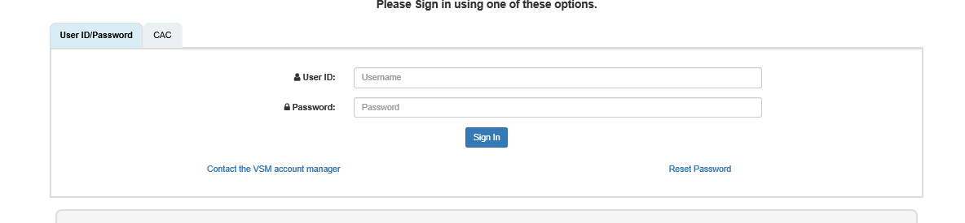
If you do not have a PIN click the: I do NOT have a PIN, please send me one. Radio button and then click Submit
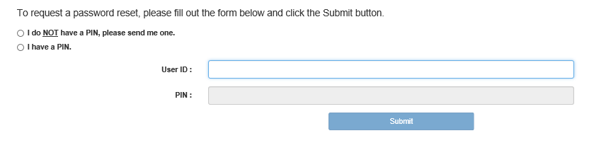
- Once you receive the PIN:
a. Follow the first step and then once you get to the password reset screen click the I have a PIN and the enter your user ID and then the PIN you received. Click the Submit button and then it will take you to the Create a Password Screen.
- If this does not work :
  - Contact VSM by contacting the appropriate agency:
    - DLA 1-800-456-5507 or email: delivery@dla.mil
    - DCMA 1-314-331-5573 or email: dcma.stlouis-mo.central-rc.mbx.VSM-Shipments-Transportation@mail.mil?subject=DCMA Customer Support

- If locked out for 45 days or more:
  - Contact VSM by contacting the appropriate agency:
    - DLA 1-800-456-5507 or email: delivery@dla.mil
    - DCMA 1-314-331-5573 or email: dcma.stlouis-mo.central-rc.mbx.VSM-Shipments-Transportation@mail.mil?subject=DCMA Customer Support

Back to Top

What is the status of my shipment?
- Contact VSM by contacting the appropriate agency:
  - DLA 1-800-456-5507 or email: delivery@dla.mil
  - DCMA 1-314-331-5573 or email: dcma.stlouis-mo.central-rc.mbx.VSM-Shipments-Transportation@mail.mil?subject=DCMA Customer Support
  - If no response within seven (7) calendar days, follow up by phone or email

Back to Top

My shipment was not picked up?
- Contact VSM by contacting the appropriate agency:
  - DLA 1-800-456-5507 or email: delivery@dla.mil
  - DCMA 1-314-331-5573 or email: dcma.stlouis-mo.central-rc.mbx.VSM-Shipments-Transportation@mail.mil?subject=DCMA Customer Support

Back to Top

My shipment is not ready for pickup.
- Follow directions for cancelling a shipment.
- Process your shipment when you are ready to ship.

Back to Top

My Ship To address appears to be incorrect.
- 1 Contact VSM by contacting the appropriate agency:
  - DLA 1-800-456-5507 or email: delivery@dla.mil
  - DCMA 1-314-331-5573 or email: dcma.stlouis-mo.central-rc.mbx.VSM-Shipments-Transportation@mail.mil?subject=DCMA Customer Support

Back to Top

My labels are incorrect.
- Contact VSM by contacting the appropriate agency:
  - DLA 1-800-456-5507 or email: delivery@dla.mil
  - DCMA 1-314-331-5573 or email: dcma.stlouis-mo.central-rc.mbx.VSM-Shipments-Transportation@mail.mil?subject=DCMA Customer Support

Back to Top

SHELF LIFE
The material I am shipping has a shelf life. Where do I enter the correct dates so that the shelf life will appear on the appropriate labels?

Click on the shipment you wish to process and click the Item Labels radio button. Then click submit
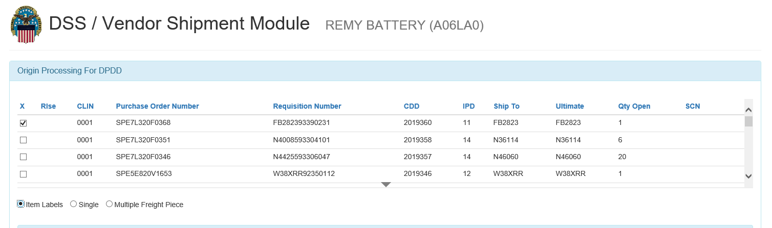

Here you will enter all the pertinent data for Shelf life or other information from the Dropdown for the following:
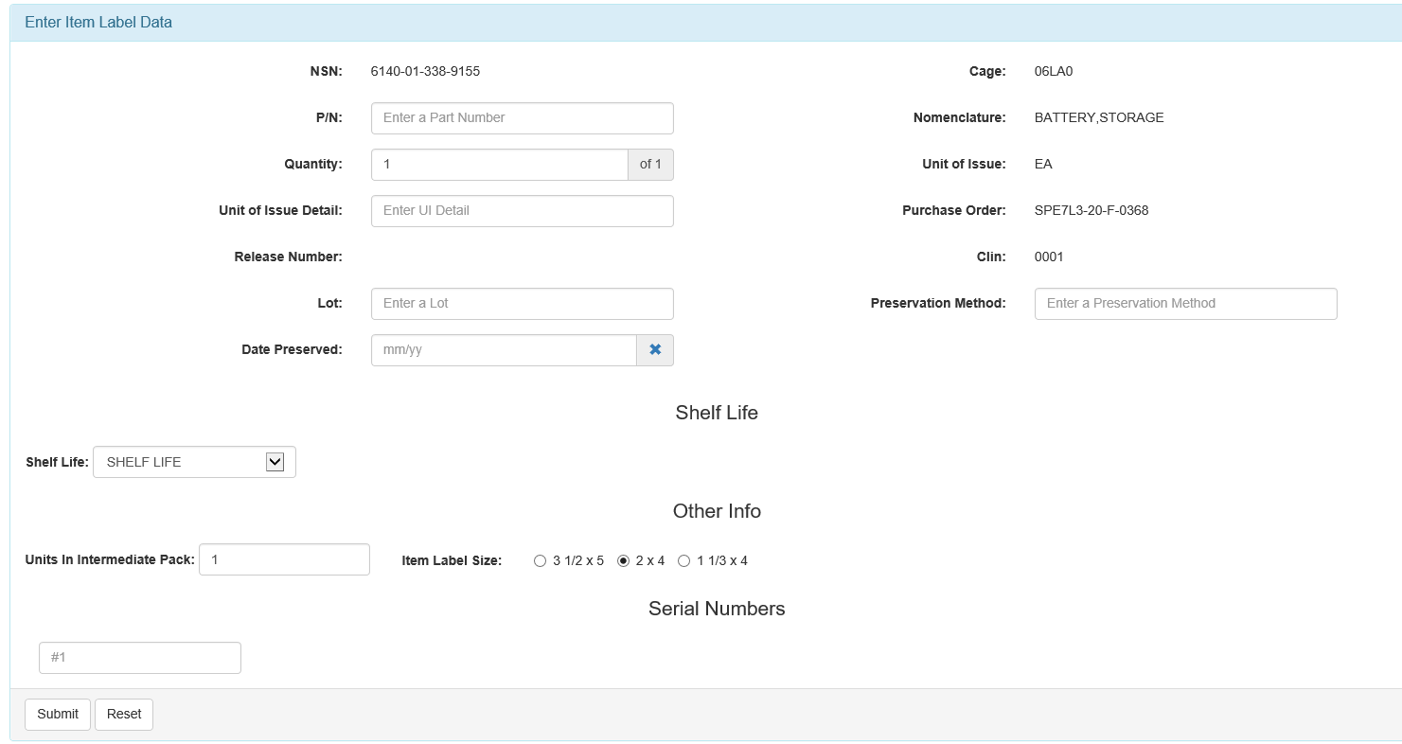
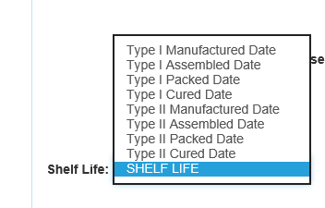
After entering all the pertinent information you will hit submit and continue to process your shipment. After completing all fields hit the submit button.

Back to Top

